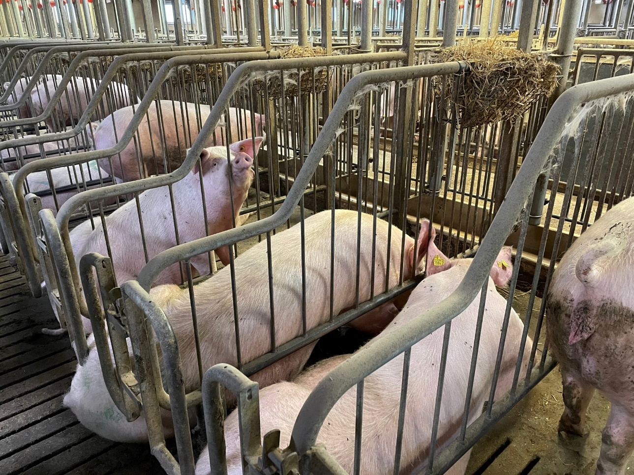

Press release:

**New EU funding for Danish sow trial**

**A new Danish EU-funded sow trial will determine why sows become more productive when fed lacto-fermented seaweed. This knowledge will help pig producers get more value from their sow feed.**

It was a joyous occasion when Danish Universities, along with the protein producer European Protein and its R&D-company Fermentationexperts, were informed that the EU had chosen to fund a new Danish sow trial.

Funding comes from the EU Commissions Horizon program, granting 9 million euros in total for the SEAMARK project and its 25 partners. The project aims to develop seaweed ingredients for feed and food.

**Investigating why lacto-fermented seaweed results in improved sow health**

The sow trial is expected to be the most extensive trial on sow health to date.

The trial will investigate what happens when the sows eat lacto-fermented rapeseed and seaweeds. CEO for Fermentationexperts and European Protein, Jens Legarth, is excited about the upcoming trial:

" We know that the sow produces more milk, and vital piglets and that inflammation level, protein level and feed consumption are reduced. But we do not know the exact modes of action as to why the sow becomes healthier and more productive with lacto-fermented protein. Together with scientists from the University of Copenhagen, Aarhus University and Aalborg University, we will learn precisely how it works".

**The trial builds on a Danish health database**

Since 2019, the University of Copenhagen and European Protein have mapped the gut health of husbandry animals, including sows and their piglets. Today, the two parties have a health database containing more than 1.000 faecal DNA and blood samples accompanied by production data and feeding strategies for more than 30.000 sows from 36 farms at their disposal. Data comes from sow herds taken both before and after feeding the fermented rapeseed protein EP199.

Now the Universities and European Protein are taking science a step further by investigating how biomarkers for health change when sows feed on lacto-fermented protein.

Professor at the Food Institute at the University of Copenhagen, Dennis Sandris Nielsen, says:

 " It is an incredible possibility to dive deeper into our research within fermented rapeseed and seaweeds. We look forward to starting - like children waiting for Christmas morning."

Aarhus University was excited as well because Post Doc and Veterinarian Marianne Kaiser believes the trial will help reduce piglet mortality:

" We have a unique chance to research the effects of fermented seaweed on sows' health and milk production. Unfortunately, sow health is still not sufficiently elucidated or prioritized when solutions to piglet mortality are being examined".

**Saves feed and protein**

The project partners hope to find answers to how pig producers cab increase health, welfare, and productivity through lacto-fermented protein. In addition, the findings will help pig producers create better results with lower feed input.

Experiences show that lacto-fermented plant protein can reduce the amount of sow and piglet feed needed while lowering the protein content of the feed:

" We must examine why sows can produce more with significantly less feed and protein. It is crucial because feed costs are rising, and here the pig producers have a potential for saving money," say's Jens Legarth when explaining the project's relevance.

**Looking for a pig producer to conduct the sow trial**

European Proteins feed advisor, Pia Sørensen and Marianne Kaiser from Aarhus University, are looking for a sow herd fit to conduct the trial.

" We are visiting sow farms matching the needs of the experiment, and where the pig producer has a genuine interest in participating in the trial, which will take a year to complete", say's Pia Sørensen.

The trial is expected to start in January 2023.

**About European protein**

European Protein is a Danish family-owned protein producer working to improve health for animals and businesses since 2011. The company produces lacto-fermented protein through biotechnology from its production sites in Denmark, Ukraine, and the US. For more information, go to [www.europeanprotein.com](http://www.europeanprotein.com)

**More information**

Jens Legarth, CEO, [jel@europeanprotein.com](mailto:jel@europeanprotein.com)

Maria Almind, Marketing Manager, [maa@europeanprotein.com](mailto:maa@europeanprotein.com)

**Images:**



1 Image of gestated sows, European Protein

2: Partners of the SEAMARK project.